**AWS Developer: The Big Picture**

Auto scaling : Use EC2 for scaling AMIs, EB for scaling application

Security group : ip based communication rules for a single or group of EC2 instances.

SG scenarios : control who can SSH into EC2 instance, allow access b/w EC2 instances, allow access to DB, allow HTTP request

EC2 Instance pricing types:

* On demand inst - cheap
* Reserved inst - cheaper
* Spot inst – cheapest

**S3 Buckets can** : trigger events when objects are added/modified/deleted, preserver older versions off objects, replicate objects across regions.

S3 can be access via URL

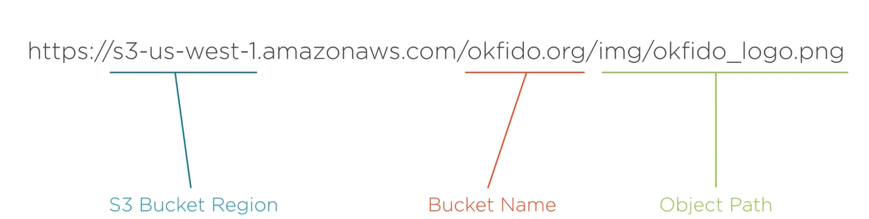

How to solve latency in S3 : use cloudfront to cache the content

S3 Pricing: Amount of data stores, number of req, amount of data transferred

**Route 53 :** The solution for your DNS needs

DNS (Domain Name system) : system that translates human-readable URLs to ip address.

EC2 inst can be config with public ip add but certain amazon resources like S3 or LB are a little more complicated and ddont have static visible ip addresses.

Route 53 allows you to set up url resolution to aws resources directly by bypassing any need for you to see an ip.

Route 53 Lets users interact with services in AWS